**Proposed solution**

***Team ID: PNT2022TMID39204***

***Date: 15-11-2022***

**Abstract**

Internet of Things (IoT) is present and future of every field impacting everyone’s life by making everything intelligent. It is a network of different devices which make a self-configuring network. The new developments of Smart Farming with use of IoT, by day turning the face of conventional agriculture methods by not only making it optimal but also making it cost efficient for farmers and reducing crop wastage. The aim is to propose a technology which can generate messages on different platforms to notify farmers. The product will assist farmers by getting live data (Temperature, humidity, soil moisture, UV index, IR) from the farmland to take necessary steps to enable them to do smart farming by also increasing their crop yields and saving resources (water, fertilizers). The product proposed in this paper uses ESP32s Node MCU, breadboard, DHT11 Temperature and Humidity Sensor, Soil Moisture Sensor, SI1145 Digital UV Index / IR / Visible Light Sensor, Jumper wires, LEDs and live data feed can be monitored on serial monitor and Blynk mobile. This will allow farmer to manage their crop with new age in farming.

*Keywords:* Smart Farming, Internet of Things (IoT), ESP32s, DHT11 Temperature and Humidity Sensor, Soil Moisture Sensor, SI1145 Digital UV Index / IR / Visible Light Sensor

# Introduction

The future of Smart Computing will be completely based on Internet of Things (IoT). It has a crucial role of transforming “Traditional Technology” from homes to offices to “Next Generation Everywhere Computing”. ‘Internet of Things’ is gaining an important place in research across the world and specially in area of advanced

wireless communications. Today IoT has started touching people everywhere and,

transportation, agriculture and business management and many other see in figure 1. (As stated by Nayyar Anand [1]) The most researched are of IoT is agriculture. Because it is really crucial sector to ensure the food security as global population is increasing rapidly. Researchers first started applying ICT based technique in this sector, which were useful on some levels but definitely was not going to solve our problem in long run. So now, they are exploring IoT as an option to ICT in agriculture. Agriculture products need applications like soil moisture monitoring, environmental condition monitoring for temperature, moisture, supply chain management and infrastructure management.The future of agriculture is precision agriculture and it is expected to grow at 4 billion by 2020. Data generated from sensors on agriculture field can also be used for Data analytics, which will help farmers to improve crop yields. So, IoT based smart farming can solve many agricultures-based issues. The aim of this paper is to introduce a working product which will allow farmers to real time data.The structure of the paper is as follows: Section 2 will have the significance of IoT based applications in Smart Farming and its benefits as well as short comings of the product based on IoT. Section 3 will have the sensors, microcontroller and other hardware items used to create the product with the brief information with images. As this product is a working product, there will be pictures of the prototype model. Section 4 will give us the idea about the working of the product and the is test dataset which was measured during the testing of the prototype model. Section 5 will cover conclusion and future scope in the product with the advancements in IoT.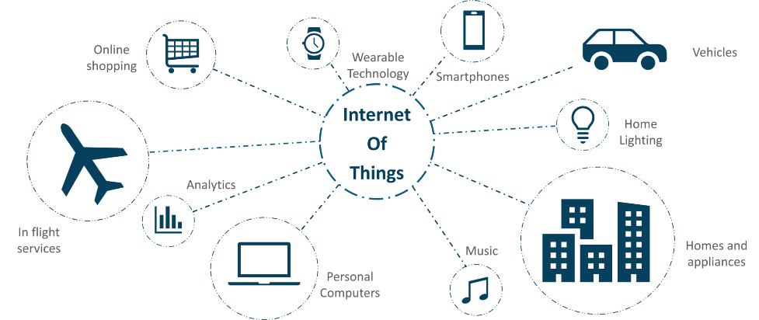

# IoT in Smart Farming

Smart farming is a modern farming managemental concept with IoT technology to increase the productivity in agriculture. With the use of smart farming, farmers can effectively use fertilizers and other resources to increase the quality and quantity of their crops. Farmers cannot be physically present on the field 24 hours a day. Also, the farmers may The future of agriculture is precision agriculture and it is expected to grow at 4 billion by 2020. Data generated from sensors on agriculture field can also be used for Data analytics, which will help farmers to improve crop yields. So, IoT based smart farming can solve many agricultures-based issues. The aim of this paper is to introduce a working product which will allow farmers to real time data.

The structure of the paper is as follows: Section 2 will have the significance of IoT based applications in Smart Farming and its benefits as well as short comings of the product based on IoT. Section 3 will have the sensors, microcontroller and other hardware items used to create the product with the brief information with images. As this product is a working product, there will be pictures of the prototype model. Section 4 will give us the idea about the working of the product and the is test dataset which was measured during the testing of the prototype model. Section 5 will cover conclusion and future scope in the product with the advancements in IoT.

Not have the knowledge to use different tools to measure the ideal environmental conditions for their crops. IoT provides them with the automated system which can function without any human supervision and can notify them to make proper decision to deal with different kind of problems they may face during farming. It has the capability to reach and notify the farmer even if farmer is not on the field, which can allow farmer to manage more farmland, thus improving their production.

IoT applications in smart farming also includes farm vehicle tracking, livestock monitoring, storage monitoring and other farm options. There can be extensive use of Smart Organic Farming which is currently in trend across the world which shows that it is not only restricted to large farming operations.

* 1. *Benefits of Smart Farming*

People are still working on different Smart Farming technology using IoT, so the anticipated benefits of this technology are, Remote monitoring for farmers, water and other natural resource conservation, good management also allows improved livestock farming, the things which are not visible to necked eye can be seen resulting is accurate farmland and crop evaluation, good quality as well as improved quantity, the facility to get the real- time data for useful insights.

* 1. *Shortfalls of Smart Farming*
     + Agriculture being a natural phenomenon relies mostly on nature, and man predict or control nature let it be rain drought sunlight availability. pests control etc. So ever implementation IoT system agriculture.
     + The smart agriculture need availability on internet continuously. Rural part of the developing countries did

not fulfil this requirement. Moreover, internet is slower.

* + - Fault sensor or data processing engines can cause faulty l decisions which may lead to over use of water, fertilizers and other wastage of resources.
    - The smart farming-based equipment require farmer to understand and learn the use of technology. This is

the major challenge in adopting smart agriculture framing at large scale across the continues.

* **Components used in proposed product**
  1. *Definition of our product*

This device monitors the farm or greenhouse and based upon the readings of different kind of sensors like temperature, humidity, soil moisture, UV, IR, soil nutrients and gives different types of messages to the farmer about the present conditions so that the farmer can take quick action. The quick actions taken by the farmers will help them increase the productivity in their farming and proper use of natural resources will be done, which will make our product environment friendly also. Our product will increase the quantity and quality of the crops by

properly monitoring the various present conditions. It is an IoT device with the concept of “Plug and Sense”. Live data for different parameters can be seen on Laptop and Smart Phones.

* 1. ***Different Components***
     + 1. *ESP32s Node MCU*
       2. *Breadboard*
       3. *DHT11 Temperature and Humidity Sensor*
       4. *Soil Moisture Sensor*
       5. *SI1145 sensor for UV/ IR and visible light index*
       6. *LEDs*
       7. *KY-006 passive buzzer*
       8. *Power Supply-Power Ba*nk

# Implementation

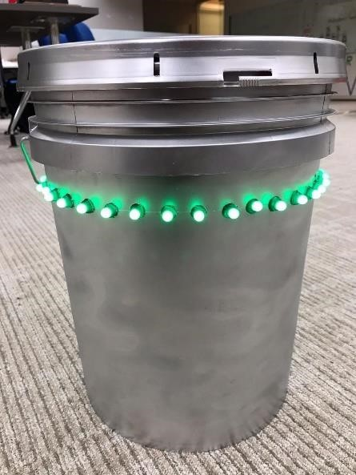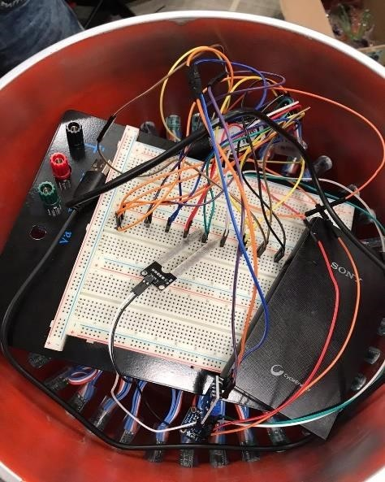Our aim was to create a prototype model, which can be easily installable in the field and is also easy to use as farmers might not have the technical knowledge. With the use of IoT the system is automated.

In Fig 2. (a), as you can see, it is the inside view of the prototype model where all the sensors and ESP32s are connected via breadboard and the power bank is used for power supply. (b), the outside view of the model with LEDs and in (c) we have put a snapshot of Blynk app window which is showing humidity and temperature. In the same way we can have different windows to monitor live feed from different sensors, create graphs for further analysis as well.

1. We used ESP32s node MCU, which is wireless and Wi-Fi enable.
2. On breadboard, we connected the ESP and DHT11 temperature and humidity sensor, soil moisture sensor, buzzer, LEDs and SI1145 Digital UV Index / IR / Visible Light Sensor with the help of jumper wires.
3. ESP32 goes to sleep after every 18 minutes, wakes up, takes the reading, upload it on the Blynk app cloud to feed the live data and goes to sleep mode again.
4. The LEDs retain the state so when the farmer passes through if he didn’t hear the sound or got the notification on phone can look the LEDs to take the necessary steps. Where turning red, blue or violet will give different indications. Same as one buzzer sound signals something, two means something else.
5. In the prototype model, bucket is used. Here the soil moisture sensor is fitted at the bottom and temperature humidity sensor, Digital UV Index sensor and the buzzer are placed at the top by putting a whole in the cover.
6. We give power with the help of a 6000 mAh power bank, so after uploading the code the system works on itself.
7. The sleep mode also helps to save power to increase the life of the power bank. So, what difference does it make in terms of total duration? To see that we will need power consumption for every component used in the prototype. The details about every component is as follows,

We are using ESP32, which has a power pin of 3.3V as well as 5V, here we connect sensors to 5V pin and the max operating voltage of the sensors are 5V. Now, for the power consumption calculation we need currents as well. Operating current for every component is as follows.

* + ESP32s node MCU (Active mode)- 40mA (CPU + electronics)
  + ESP32s node MCU (sleep mode)- 3.5 mA (sleep + electronics)
  + DHT11-1.5mA
  + Soil moisture- 5 mA
  + UV light/IR sensor- 2 mA
  + LED stipe (12V LEDs)- 1mA

Calculation of power consumption per hour for sleep mode, (2 minutes active, 18 minutes sleep mode)

= 54/60*(3.5+1.5+5+2+1) + 6/60*(40+1.5+5+2+1)

=54/60(13) + 1/10*(49.5)

=16.65 mA per hour

When we used 6000mAh power bank, So now capacity=6000 mAh

Formulae, Capacity=Amp*hours(current*time) So, Hours= 6000/16.65

=360.36

Converting that to days,

=360.36/24

=15 days approx.

Calculation of power consumption per hour for active mode,

=49.5 amps In days,

=6000/49.5*24

=5 days

Thus, by entering sleep mode life of the power bank gets extended by 10 days

# Future Work

# Soil and crop monitoring have been at the front and center of smart farming solutions. In its most basic form, a crop monitoring solution may only include a few moisture sensors connected to an IoT dashboard and configured to send an alert whenever your plants need watering. However, real-life applications are usually more complex. In addition to soil moisture levels, it is also common to monitor ambient temperature and humidity, soil temperature, soil electrical conductivity, and lighting intensity. As a next step, such solutions can be enhanced with the ability to remotely control devices such as sprinkles, smart lights, heaters, air conditioners, fertilizer spreaders, etc. Whenever certain sensor data goes beyond normal, these devices can be engaged to fix the issue.

# By using an end-to-end IoT platform like Kaa, you can connect all the sensors and devices you need to have an integrated solution for your field, garden, or greenhouse. The platform also features advanced analytics that will let you analyze historical trends and optimize your farming practices based on actual data.

# Here’s how you can ensure the best soil-plant relationship with Kaa:

# Sensor data monitoring (temperature, humidity, soil moisture and EC, light, etc.)

# Remotely controlled irrigation

# Greenhouse climate control

# Smart lighting

# Smart alerts and notifications

# Historical data analytics

# Conclusion

From our results and literature survey of other papers, we saw that the hardware and materials we used to develop our porotype allowed us to make an efficient and accurate, as well as cheap product for farmers. Which was economical and easily installable for farmers as well. Thus, we can conclude that this porotype will definitely help farmers in small farmland to effectively monitor their crops with the user-friendly app and other alert means.

# References

1. Nayyar, Anand & Puri, Vikram. (2016). Smart farming: IoT based smart sensors agriculture stick for live temperature and moisture monitoring using Arduino, cloud computing & solar technology, The international conference on communication and computing (ICCCS-2016)
2. Gorli, Ravi & Yamini G. (2017). Future of Smart Farming with Internet of Things. Journal of Information technology and Its Applications. Volume 2, Issue 1, Page 2738
3. S. jegadeesan, dr. g. k. d. Prasanna venkatesan Smart cow health monitoring, farm environmental monitoring and control system using wireless sensor networks, International journal of advanced engineering technology, Jan-March 2016, page 334-339
4. IoT based agriculture monitoring and smart irrigation system using raspberry pi, International Research Journal of Engineering and Technology (IRJET), Volume: 05(01), Jan-2018, Page 1417
5. Jirapond Muangprathub,Nathaphon Boonnam et al ,Computers and electronics in agriculture, computers and electronics in agriculture original papers IoT and agriculture data analysis for smart farm, volume 156, January 2019, pages 467-474
6. Panel. Mohanraja Kirthika Ashokumarb and J. Narenc, Procedia Computer Science Field Monitoring and Automation Using IOT in Agriculture Domain, Procedia Computer Science Volume 93, 2016, Pages 931-939
7. Vaibhavraj S. Roham, Ganesh Pawar, Abhijit Patil & Prasad Rupnar, Smart Farm using Wireless Sensor Network, International Journal of Computer Applications, National Conference on Advances in Computing, NCAC 2015
8. Prem Prakash Jayaraman, Ali Yavari, Dimitrios Georgakopoulos, Ahsan Morshed & Arkady Zaslavsky, Internet of Things Platform for Smart Farming: Experiences and Lessons Learnt, Sensors 2016, 16, 1884; doi:10.3390/s16111884
9. Janna Huuskonen, Timo Oksanen, Soil sampling with drones and augmented reality in precision agriculture, Computers and electronics in agriculture, Volume 154, Pages 25-35
10. IoT in smart farming <https[://w](http://www.iotforall.com/iot-applications-in-agriculture/amp/)ww[.iotfo](http://www.iotforall.com/iot-applications-in-agriculture/amp/)r[all.com/iot-applications-in-agriculture/amp/](http://www.iotforall.com/iot-applications-in-agriculture/amp/)> (Visited on 5th July, 2019)
11. ESP32 Document

<https://[www.espressif.com/sites/default/files/documentation/esp32_datasheet_en.pdf](http://www.espressif.com/sites/default/files/documentation/esp32_datasheet_en.pdf)> (visited on 5th July, 2019)

1. IoT application diagram <https://[www.edureka.co/blog/iot-applications/](http://www.edureka.co/blog/iot-applications/)> (visited on 7th of July,2019)